CS-23334 FUNDAMENTALS OF DATA SCIENCE
ASHWIN C 240701058

EXPERIMENT 10 Date: 02.10.2025

10. Experiment to understand K-means clustering algorithm for a given data set.

Aim:
To conduct experiment to understand K-Means Clustering Algorithm for a given data set

Description:
Understand the K-Means Clustering algorithm for the dataset given.

Algorithm:
Step 1: Select Features and Preprocess the Data
Step 2: Choose the Number of Clusters (K)
Step 3: Apply the K-Means Algorithm and Fit the Model
Step 4: Visualize Clusters and Centroids
Step 5: Interpret Cluster Assignments and Evaluate Results

About Dataset:
This dataset contains customer demographic and behavioral data, including Customer ID, Gender, Age, Annual Income (in thousands), and a Spending Score from 1 to 100.

Code With Output:

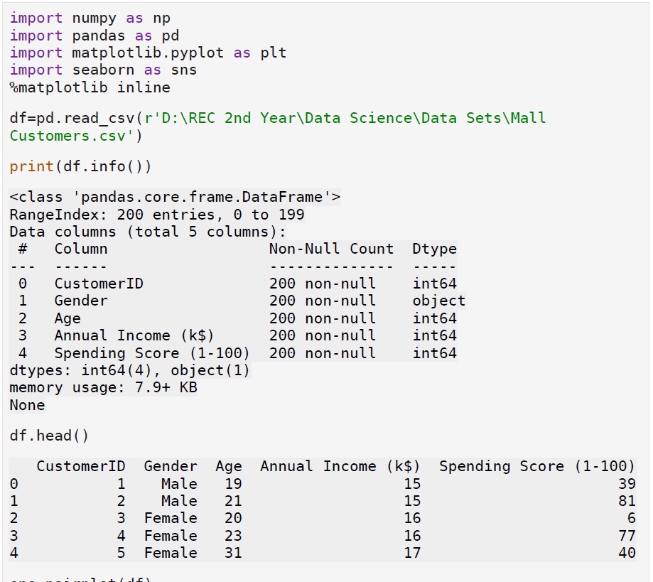

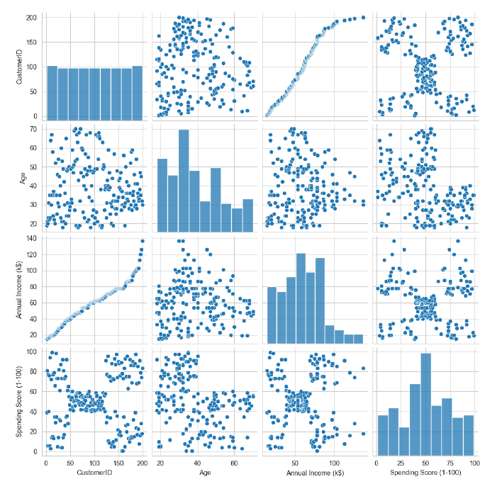

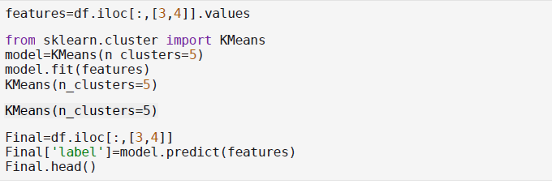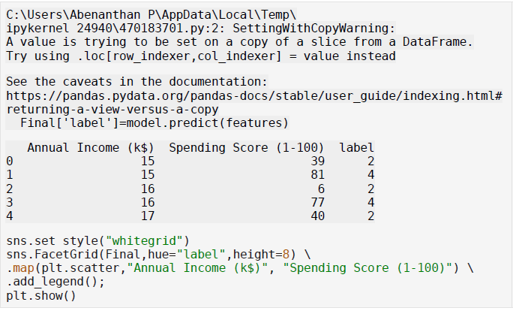
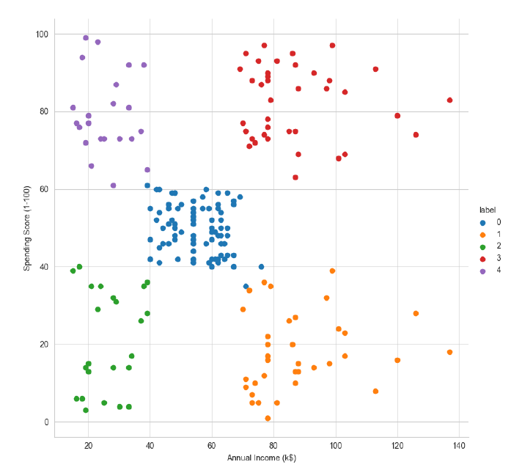

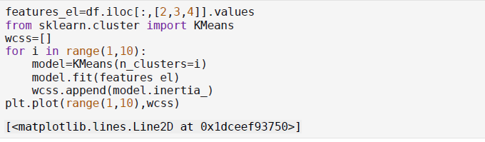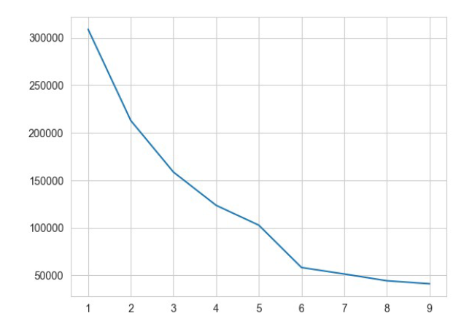
Result:
Thus python program to understand K-Means Clustering algorithm for dataset is conducted successfully

